(Area/Division) Speech Contest
Table Topics and Tall Tales Speech

When: Tuesday, October 24th, 2020

Where: Venue
123 Main St
Plymouth, MN 55442

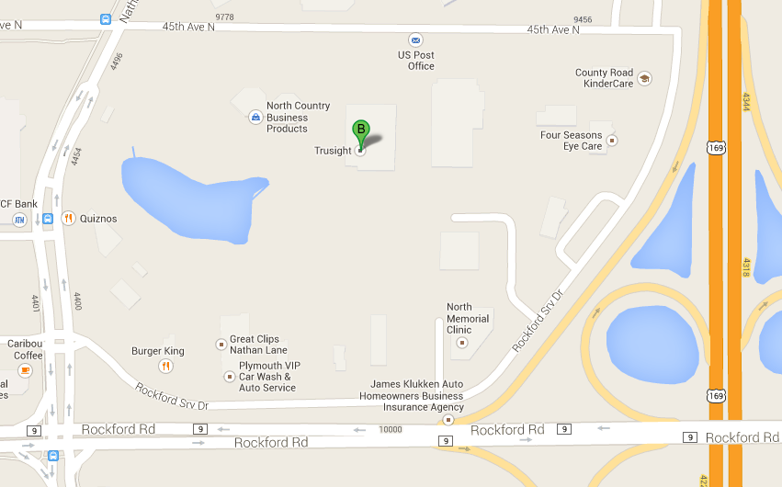

Host Club: (Club Name/Number)

Program: Registration Opens: 6:00 pm
Briefings Begin: 6:30 pm
Contest Starts: 7:00 pm
Contest Finishes: 9:30 pm

Cost: Free will donation

Refreshments: Light refreshments will be provided.

RSVP: (Name)
Email:
Phone:

Join us for a fun evening!

