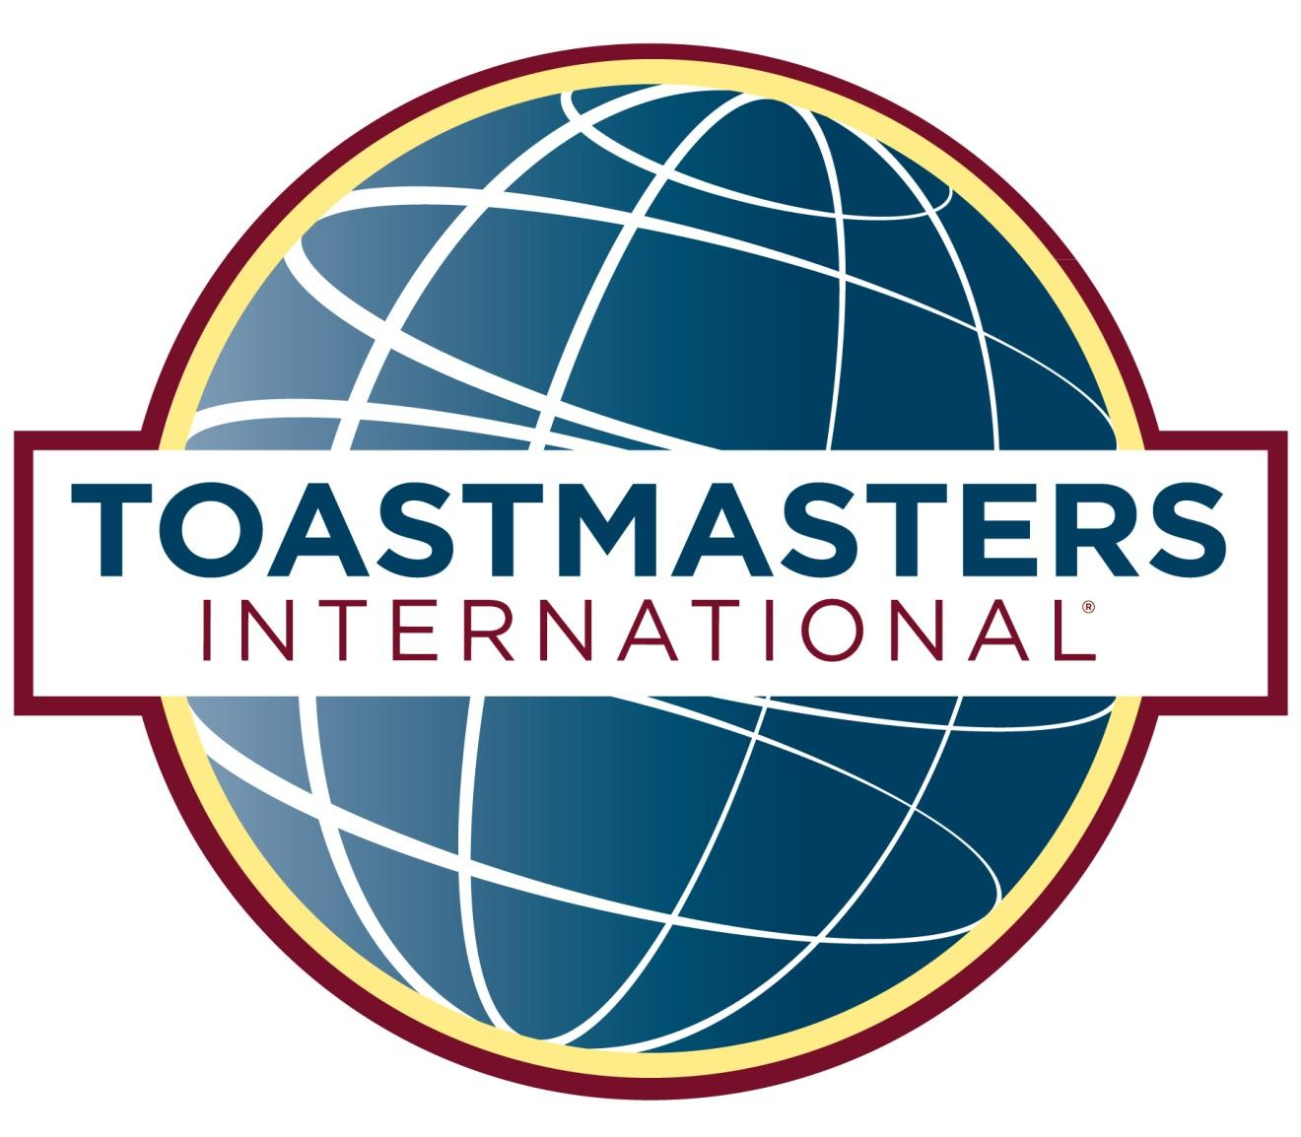
(Club/Area/Division)
Speech Contests

