CLUB EXTENSION
OPERATING MANUAL

DISTRICT 106
Serving Parts of Minnesota and Ontario, Canada

DEVELOPED BY
Club Extension Committee 2020-21
Ed Aylward, DTM Club Extension Chair
Gopu Shrestha, DTM, Club Growth Director 2020-21

table of contents
Table of Contents
1 Introduction and Welcome 3
1.1 Role of Chair and Committee 3
1.2 Gathering Volunteers 3
1.3 Backup Plan to fill out Volunteers 3
1.4 Invitation and Distribution 3
1.5 Agenda Preparation 4
1.6 Post Demo Meeting 4
1.7 Next Schedule Meeting 4
2 Demo Meeting Agenda 4
3 The District Support Team 5
3.1 Club Sponsor Chair 6
3.2 Club Growth Director 6
3.3 Division Directors 6
3.4 Area Directors 6

Introduction and Welcome

Congratulations on becoming a club extension committee member to help new clubs and people who want to develop communication and leadership skills.!

Role of Chair and Committee

Club Extension Chair oversees the objectives for the Club Extension and Club Sponsor Committees. These two committees are essential in assisting the Club Growth Director through maintaining quality leads and providing guidance over the club sponsor program to ensure that prospective clubs are chartered successfully.

In addition to providing sponsors for prospective clubs, the club sponsor committee arranges club sponsor credit opportunities for members who seek it.

Club Extension Committee - This committee is responsible for one of the most important aspects of the District’s marketing strategy—qualifying, managing and tracking leads. Members of this team:
- Manage all credible new club leads within the boundaries of their District
- Contact, follow up with and track the status of all leads/opportunities
- Schedule and staff all demonstration meetings

Gathering Volunteers
Communicate with team of 15 to 20 Toastmasters regarding their availability on specific dates to fill roles in demonstration meetings for new clubs wanting to charter.

Backup Plan to fill out Volunteers
Reach out to contacts from home Toastmasters club, other nearby clubs, other Toastmaster acquaintances and friends to fill demonstration meeting roles not filled from the 16-person committee.

Invitation and Distribution
Get Tentative Schedule from proposed club time frame and get confirmation from volunteers.

Obtain and distribute zoom or Microsoft Teams link

Agenda Preparation
Prepare a draft agenda (Appendix A: Sample Agenda) and share with volunteers.
Get at least one speaker from proposed club

Post Demo Meeting
In association with Club Growth director, Share details like contact person, volunteers with Club Sponsors / Club Mentors.

Next Schedule Meeting

After two weeks, follow up with Club Growth Director for next round of meeting. Ensure, proposed club is ready to supply some volunteers to next round of meetings.

Demo Meeting Agenda

Sample Agenda

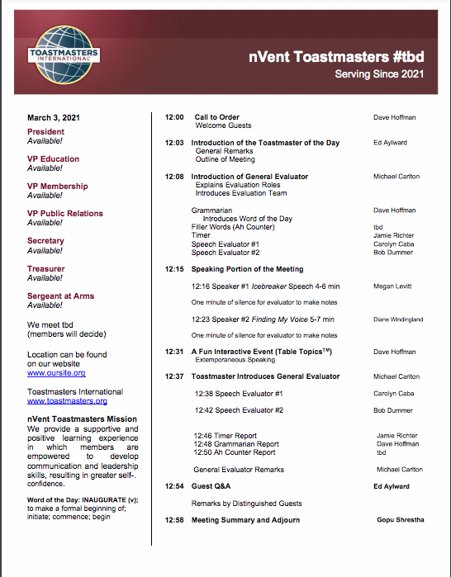

Things to Consider - Volunteers
Ensure every role speaks what is their role and how they are executing role like
- Timer role is to keep meeting on track so every speaker are time bound
- Ah Counter / Grammarian is developing listening skills to help speakers to avoid filler words in format speech
- Evaluator is to develop listening skills and present a constructive feedback so the speakers can come up with better speech next time
- Table topics masters is to serve as a person to provide opportunities to speak specially members’ who doesn’t has any roles to speak. Simultaneously, develop an learning environment for members to speak while standing in feet.

Participants Involvement
- Ensure Table topics masters inspire volunteers from guests / attendees to speak at least 1 or 2 persons.
- Ensure there is enough timeslot for Q&A sessions.

The District Support Team

You are not alone as you work with your club. The district leadership wants your efforts to be successful, so that the club grows stronger and so that you can receive credit for your hard work and commitment. Please do not hesitate to reach out if you have questions or concerns.

Club Sponsor Chair

The Club Coach Chair is the primary point of contact for all club coaches in District 106. If you have any coaching related questions or problems, he is the first person to talk to. All club coaches should strive to provide a brief summary of their club’s status to the Club Coach Chair once each month.

Club Growth Director

The Club Growth Director oversees the club coach program. He is the person that must sign all club coach assignments. If the club you are working with needs additional help or is facing specific challenges, the Club Coach Chair will bring him in to help. http://d106tm.org/district/directory/

Division Directors

Division directors oversee approximately thirty total clubs each divided into a number of areas. Division directors meet regularly with the district trio and also have contact with the individual clubs. If the club you are working with needs additional help or is facing specific challenges, your area director will bring the division director in to help. http://d106tm.org/district/directory/

Area Directors

Area directors work directly with four to six clubs offering support and resources. As a club coach, you should ideally be in regular contact with the area director. Contact the area director when you are assigned to let them know you will be working with one of their clubs. You may contact the area director as needed for additional support and to keep him or her apprised of the club’s progress.

You can contact area directors through the District 106 website directory:

http://d106tm.org/district/directory/

