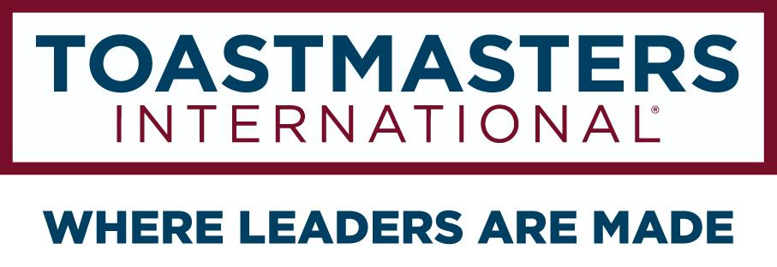

CLUB RETENTION
OPERATING MANUAL

DISTRICT 106
Serving Parts of Minnesota and Ontario, Canada

DEVELOPED BY
Ashok Sunkavali, Club Extension Chair 2020-21
--
--
--

Gopu Shrestha, DTM,
Club Growth Director 2020-21

table of contents
Table of Contents
1 Introduction and Welcome 3
1.1 Preface 3
1.2 Manual Contents 3
2 How to Form and run Committee Meeting? 3
3 How to Collect Low Member Club 3
3.1 Download from dashboard 3
3.2 Subscribe Mike Raffety email 4
4 Club Assessment 4
5 Update Records and Status 5
6 Execution and Follow up 5
7 Best Membership Drive Program 5
8 Material Developed by Toastmasters 6
9 The District Support Team 6
9.1 Club Sponsor Chair 7
9.2 Club Growth Director 7
9.3 Division Directors 7
9.4 Area Directors 7

Introduction and Welcome

The Club Retention Chair’s key role is to figure out low member clubs and find out the issues clubs are facing. Based on that information coordinate with Club Growth Director, Area Director and Division Director to run membership drive programs to rebuild the club in charter strength.

Congratulations on becoming a club sponsor to help new clubs and people who want to develop communication and leadership skills.!

Preface
The Club Retention Chair assists with promoting membership building programs designed by Toastmasters International (Smedley Award, Talk Up Toastmasters and Beat the Clock), and additional programs designed by the District.

How to Form and run Committee Meeting?
Toastmasters is a learning and developmental organization therefore, we work in a team and share ideas to achieve a common goal “Develop Communication and Leadership Organization”. In coordination with Club Growth Director, Club Retention Chair should form a committee and share responsibilities.

Chair take a lead and call meeting once in a month to share the status and develop next month stragegy.
Agenda could be around
- Club’s Response
- Club’s Expectations
- District Officer Response (specially Area Director)
- Training Resources Availability

How to Collect Low Member Club

Download from dashboard

In coordination with Club Growth Director, Retention Chair get the list from WHQ website http://dashboards.toastmasters.org/Division.aspx?id=106
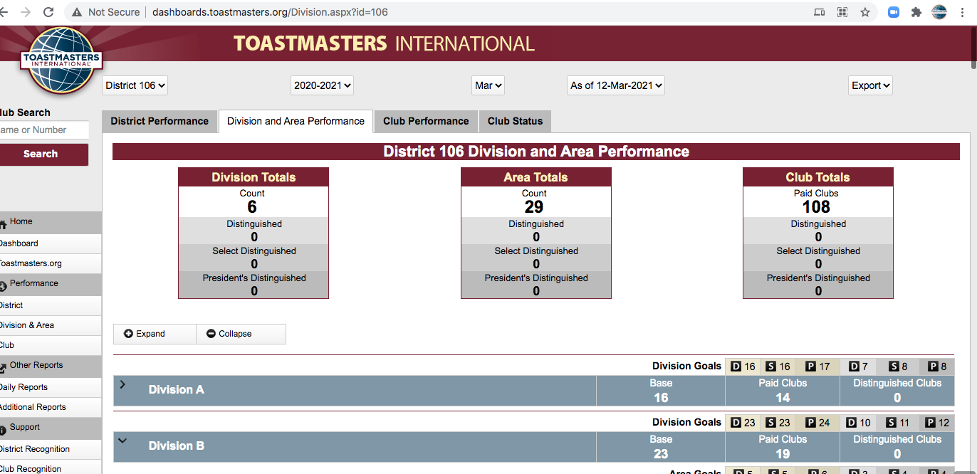

Subscribe Mike Raffety email

Email: mike@mikeraffety.com
Mike send email monthly about the status of club specially
- Membership Club Goal, Area Goal, District Goal
- Distinguished Goals
- Clubs Needed Coaches
- Highest Education awarded Goals
- Area wise analysis

This will be a great update to review.

Club Assessment
Club retention committee should do an assessment for any club based on the following criteria.

- Do they have a functionally run Website?
- Do they ever run Moment of Truth?
- Do they asked for Coach ? or have Coach? Is Coach Effective?
- Do they have Mentoring club members in place?
- Do they do Open Houses?
- Do they do Speech Crafts once in a year?
- Do they invite Guest Speakers?
- Do they send or provide Digital Guest Packet?

Update Records and Status

Committee need to update the activities they done and update to CGD. This way district will know that what is going on and what resources is needed.

A sample assessment form could be as follows:
Div | Area | Club # | Club Name | Committee Member | Website | Mot | Coach | Mentor | Open House | Speech Craft | Guest Speakers

An activities logs can be as follows:
Division | Area | Club # | Club Name |  | Correspondence Dt.
 |  |  |  | Committee Member | Introductory Email Dt. | Follow up Dt.

Execution and Follow up

Based on clubs’ demand and willingness coordinate with Area Director and CGD to do activities like –
- Speech Craft, contact Speech Craft Coordinator
- Open House, check if any volunteers in district can do “how to run effective Open house”
- Deliver speech regarding “Moment of Truth”
- Reach our Club Coach Chair for club coaching
- Speeches on “Mentoring Session”
- Update Club Website and help to get club website from freetoasthost.org https://www.toastmastersclubs.org/welcome/whats_new.html
- Encouraged to invite guest speakers. Coordinate with CGD for speakers in District

Best Membership Drive Program
Here are some tips extracted from best practices:

- Partnership with internal groups.
If you’re a corporate club, it’s very likely there are other networks and groups internally that can work together. If a group is holding an event and someone needs to speak, a toastmaster can certainly help.
- Marketing Campaign.
Sometimes people just need to know these meetings exist and regularly meet. If you have consistency, then guests will come and practice.
- Internal newsletter.
- Add your toastmasters group to an internal newsletter. Write your own newsletter and share it.
- Add to new hire process.
- Website updates (tweets of meeting times with reminders)
- Transparency of recognition and awards. Send messages to toastmaster members’ managers of their milestones to improve communication skills.
- Physical poster in the lobby reminding people of the meeting for the day.
- Mentorship program.
Officers who are more advanced speakers can take on mentees and meet with them to complete their goals.
- Video/Recording – It’s always a great motivation to improve your public speaking when you see/hear a recording of yourself. You are your own worst judge.
- Guest packet: A package to guest/visitors with an FAQ. Some questions may include:
- What is toastmasters?
- What is the meeting format?
- How do members benefit?
- What is the CC?
- What is the CL?
- When does toastmasters meet?
- How do I join?
Digital Guest Packet also available in TI Website “Digital Guest Packet Link”

Material Developed by Toastmasters

Search with following name or click to this link.
- Moments Of Truth (Item 290)
- Finding New Members For Your Club (Item 291)
- Evaluate To Motivate (Item 292)
- Closing The Sale (Item 293)
- Creating The Best Club Climate (Item 294)
- Meeting Roles And Responsibilities (Item 295)
- Mentoring (Item 296)
- Keeping The Commitment (Item 297)
- Going Beyond Our Club (Item 298)
- How To Be A Distinguished Club (Item 299)
- The Toastmasters Educational Program (Item 300)

The District Support Team

You are not alone as you work with your club. The district leadership wants your efforts to be successful, so that the club grows stronger and so that you can receive credit for your hard work and commitment. Please do not hesitate to reach out if you have questions or concerns.

Club Sponsor Chair

The Club Coach Chair is the primary point of contact for all club coaches in District 106. If you have any coaching related questions or problems, he is the first person to talk to. All club coaches should strive to provide a brief summary of their club’s status to the Club Coach Chair once each month.

Club Growth Director

The Club Growth Director oversees the club coach program. He is the person that must sign all club coach assignments. If the club you are working with needs additional help or is facing specific challenges, the Club Coach Chair will bring him in to help. http://d106tm.org/district/directory/

Division Directors

Division directors oversee approximately thirty total clubs each divided into a number of areas. Division directors meet regularly with the district trio and also have contact with the individual clubs. If the club you are working with needs additional help or is facing specific challenges, your area director will bring the division director in to help. http://d106tm.org/district/directory/

Area Directors

Area directors work directly with four to six clubs offering support and resources. As a club coach, you should ideally be in regular contact with the area director. Contact the area director when you are assigned to let them know you will be working with one of their clubs. You may contact the area director as needed for additional support and to keep him or her apprised of the club’s progress.

You can contact area directors through the District 106 website directory:

http://d106tm.org/district/directory/

