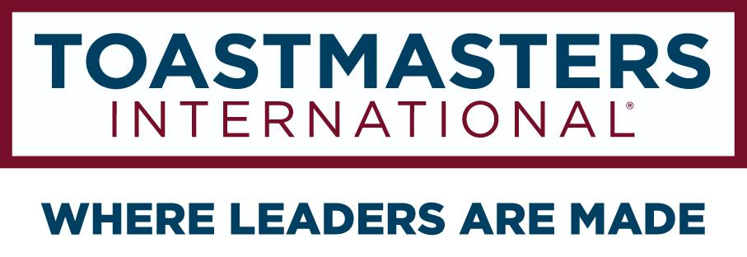

CLUB SPONSOR
OPERATING MANUAL

DISTRICT 106
Serving Parts of Minnesota and Ontario, Canada

DEVELOPED BY
Club Sponsor Committee 2020-21

Arthur Goldstein, Club Sponsor Chair
Kent Hawks
George Kane
Mike Dupris
Edward Aylward
Anne Groetsch
Keith Hardy

Gopu Shrestha, DTM,
Club Growth Director 2020-21

table of contents
Table of Contents
1 Introduction 2
1.1 Welcome 2
1.2 Role of the Committee 2
2 How to find Potential Clubs 3
3 Corporate Master List 3
4 How to interview Club Sponsor / Mentor? 4
5 Resources Developed by Toastmasters International 4
5.1.1 All about Toastmasters 4
5.1.2 How to Sponsor A New Club 4
5.1.3 Club Sponsor, Mentor, and Coach Training 4
5.1.4 How to start a club? 4
6 Cold Calling Script 4
7 Committee Meeting Format 6
8 The District Support Team 6
8.1 Club Sponsor Chair 6
8.2 Club Growth Director 6
8.3 Division Directors 6
8.4 Area Directors 7

Introduction

The club sponsorship committee finds groups that are interested in creating new Toastmasters clubs and pairs them with Toastmasters members who will be their sponsors and help guide the potential club to chartering.

This manual covers the steps that could be used to find and create a club. Depending on the situation, i.e. a club wants to be chartered and is looking for sponsors some steps would be skipped.

Welcome
Congratulations on becoming a club sponsor committee member to help new clubs and people who want to develop communication and leadership skills.!

Role of the Committee

A club sponsor is responsible for organizing a new club, including setting up regular club meetings, completing the paperwork, and plan the charter presentation. A new club needs 20 paid members and a charter fee. Full details are in the documents referred to in the Toastmasters links section.

Club Sponsor Committee - This committee recruits, trains, and tracks sponsors for all clubs that charter or are in the midst of the chartering process. Members of this team:
- Recruit and assign club sponsors to new club opportunities in the District
- Understand and facilitate club sponsor training; refine the curriculum and assist sponsors to ensure clubs are served effectively
- Work with club sponsors to collect the required chartering funds and ensure they receive club sponsoring credit from WHQ

How to find Potential Clubs

The committee maintains a spreadsheet of groups that may be interested in having a Toastmasters club. The spreadsheet can be access from google drive

Access to the spreadsheet is limited to contactors who talk to the groups and committee members.
Each row corresponds to a group that was thought to see if they would be interested in a Toastmasters club.

The sheet may be undergoing some cleanup, there are columns that one may deem irrelevant.
Important columns include:

Contactor: who from District 106 is communicating with the group, do not want to have more than one.
Status: What results the contactor has had in contacting the group.
Contact Info: Email/Phones/People to talk to. In case the contactor changes this would be useful for the next person who becomes contactor.

If people have suggestions for groups that could use a new club and they would like the sponsorship committee to contact that group, it may be added as a new row to the spreadsheet.

There are currently many more groups that could have clubs than there are people to contact them. Contacting can also be difficult. Finding people to be contactors is an on-going process. Some are volunteers for the district. Area directors may also be asked, especially since they are spread throughout the district and can be local to the group.

Corporate Master List

D106 did a lot of research and prepared master list for companies above 250 employees and situated in geographic are of D106.

The spreadsheet can be access from google drive

How to interview Club Sponsor / Mentor?
Being a sponsor requires experience with Toastmasters, learning the official forms and process, working with others to set up a demonstration meeting, as well as commitment to ensure that the club will get off to a good start.

In coordination with Club Growth Director, this committee can conduct initial interview for potential club sponsor or club mentors. The purpose of this interview is to understand the intent of club sponsor / mentor and coach them
- What is expected task being club sponsor?
- What are the best practices to be an effective club sponsor / mentor?

Here are some sample questions you can ask:
- Please explain why new clubs get folded / close in 1-2 year or in months?
- Do you know what a quality club means?
- What are the attributes of quality meeting?
- How do you help new clubs to keep continuing the meeting after you are done with your mentoring?
- What is your action plan to help club officers to understand their role and executions?
- How can you contribute to not this club so it won't be folded?
- Ask even if your title is sponsor but you are expected to be in the club for at least 6 months to mentor and help the club stand on their own feet. Are you ok with this?
In addition, a sponsor should know the Toastmasters Club Quality Checklist linked here: https://www.toastmasters.org/Magazine/Magazine%20Issues/2019/Jan/26%20Club%20Experience

Resources Developed by Toastmasters International

All about Toastmasters

How to Sponsor A New Club

Club Sponsor, Mentor, and Coach Training

How to start a club?

Cold Calling Script

Here is the sample script. This is just a format therefore you can tweak as needed.

For the first contact with a group a sample script based off of the Toastmasters website is found here:
Your objective is to schedule an introductory meeting with the prospect.

You: Hi________, I’m ______________, an area director of Toastmasters International District 106.
How are you today?

Prospect: Hello, I am fine.
(You: Congratulations on your company being _____________. I just read about this in ________. I see that one of your major initiatives this year is ____________________, correct?

Prospect: Yes, thank you. Our company is really focused on _______________________. )

You: We specialize in working with companies like yours and we have helped with ___________________(look up other clubs near them). Toastmasters has delivered consistent results with health companies such as Aetna, Aflac, Health Net Inc., Kaiser Permanente and others.

Would you or someone else at your company be interested in knowing how we could benefit your company?
(If someone else, please collect the contact information and update the spreadsheet.)
Prospect: Sure.
You: At Toastmasters, we focus on communication and leadership skills. With every Toastmasters meeting, employees learn how to better interact with one another to successfully organize meetings in-person or remote, facilitate quality meetings and tactfully evaluate fellow employees. Would you be interested in the other benefits Toastmasters could provide to your company?
Prospect: Sure.
You: I would be happy to share this with you if it is convenient now. Are you familiar with the Toastmasters club-meeting environment?
If the prospect says no, offer a succinct explanation of what a club-meeting environment is and how it is beneficial.
If the prospect says yes, ask questions to determine if a Toastmasters club is a good fit for their company.
You: Would you be willing to offer a place for a club meeting to occur? How many employees do you have?

If the prospect passes on these qualifications, offer to meet in-person to build the relationship further.
If the prospect doesn’t pass, let them know that there are clubs in their local area and offer to send them information to promote Toastmasters internally.

You: It sounds like a Toastmasters club is a good fit for your company. Could we set a date for us to review some options in detail?
If the prospect agrees to set a meeting date, you have succeeded in meeting your objective. The next step is to follow up with an email explaining what to expect at the introductory meeting. It is important to be transparent and mindful of the prospect’s time.
The club extension committee can help set up a demonstration meeting. Currently that means contacting Club Extension Chair and Club Growth Director

Committee Meeting Format

The Sponsorship Committee should meet once a month to discuss regarding:
- How to follow up with existing Master List
- Clean up Master list (spreadsheet)
- Promotion about this committee to recruit more club sponsors
- Interview potential sponsor / mentors

The District Support Team

You are not alone as you work with your club. The district leadership wants your efforts to be successful, so that the club grows stronger and so that you can receive credit for your hard work and commitment. Please do not hesitate to reach out if you have questions or concerns.

Club Sponsor Chair

The Club Coach Chair is the primary point of contact for all club coaches in District 106. If you have any coaching related questions or problems, he is the first person to talk to. All club coaches should strive to provide a brief summary of their club’s status to the Club Coach Chair once each month.

Club Growth Director

The Club Growth Director oversees the club coach program. He is the person that must sign all club coach assignments. If the club you are working with needs additional help or is facing specific challenges, the Club Coach Chair will bring him in to help. http://d106tm.org/district/directory/

Division Directors

Division directors oversee approximately thirty total clubs each divided into a number of areas. Division directors meet regularly with the district trio and also have contact with the individual clubs. If the club you are working with needs additional help or is facing specific challenges, your area director will bring the division director in to help. http://d106tm.org/district/directory/

Area Directors

Area directors work directly with four to six clubs offering support and resources. As a club coach, you should ideally be in regular contact with the area director. Contact the area director when you are assigned to let them know you will be working with one of their clubs. You may contact the area director as needed for additional support and to keep him or her apprised of the club’s progress.

You can contact area directors through the District 106 website directory:

http://d106tm.org/district/directory/

