Duluth Club - New Member Guide
We’re excited that you are considering the Duluth Toastmasters Club to enhance your skills! Here is a list of activities to get you started in your first months as a new Toastmaster. The pace, effort and results are up to you.
- Explore
  - Info on our club website - duluth.toastmastersclubs.org
  - Public pages - toastmasters.org/about/all-about-toastmasters
  - Talk to current club members during and outside of meetings
- Become a member!
  - Fill out new member form (sign up), and send to vpm-1523@toastmastersclubs.org
  - Pay dues - More info about dues, cost and ways to pay are listed on page 2
- Get a mentor
  - After becoming a member, you’ll get member access to our club site
  - Our VP of Education or Membership will connect you with one of our current members who will be your mentor!
- Attend club meetings and start filling roles:
  - Every Thursday evening at 6:15 PM CT - Zoom link
  - Table Topics speaker
  - Timer
  - Ah-counter
  - Grammarian
- Tasks you can do with your Mentor:
  - Toastmasters International account
    - Log-in, learn basics of website
    - Sign up for Pathways and take assessment / choose a path
  - Duluth Club website
    - How to sign up for roles on club agenda
      - Give your Icebreaker (first speech)!
    - Check and edit your profile on club website
    - Private member directory, this is what you can use to reach out to other members
    - Set goals for improvement, what you want to improve
  - Meetings
    - Continue to attend and keep filling roles!
    - Ready to challenge yourself? Sign up for:
      - Table topics master
      - Speaker, again - Your second project (Using and giving evaluations)
      - Speech Evaluator
      - Toastmaster
      - General Evaluator
  - Expand your horizons
    - Learn about officer roles from current officers
    - Learn how to “complete a level” in Pathways
    - Participate in speech contests
    - Become a mentor to a new member
Most of all, keep learning and having fun!

Renewals, club dues, etc.

This snapshot may look familiar, it’s taken directly from the new member form and explains dues and fees for new members:
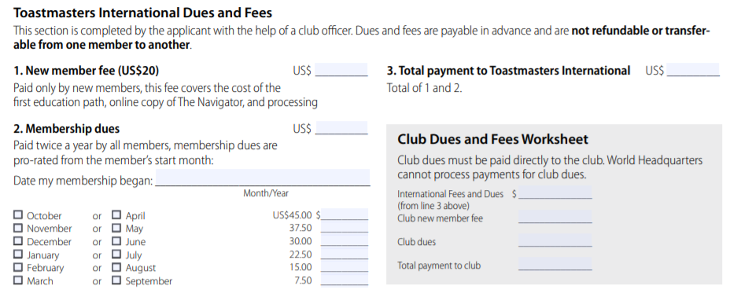

- If you’re completely new to Toastmasters, a $20 fee is owed, which goes to the cost of your first education path!
  - Are you a returning or transfer member? You don’t need to worry about this.
- Bi-annual dues
  - Based on when you want to join a club, the dues amount changes. Use the chart to verify what your bi-annual dues equal.
- Add lines 1 and 2 together to get the “Toastmasters International” amount.
- Our club charges $6 a member for “club dues”, which currently goes to pay for our Zoom account as we’re meeting remotely.

So, in short, are you new to Toastmasters and looking to join the club in April? Your total would be:
- $20 (new member fee)
- $45 (Toastmasters International fee)
- $6 (Club dues)
- = $71 total. After this, every six months, dues payments would be $51

Ways to pay:
You can make the payment to our club treasurer. Once the payment is sent to them, they will get all of your funds dispersed accordingly (to Toastmasters International and to the Club bank account).
- Venmo - @_________ -- No fee is associated if you pay through Venmo
- Paypal - @_______ -- There is a small fee included with Paypal if you choose to go through this method
- Credit Card (call the Treasurer to discuss this)
- Check (call the Treasurer for address)
Treasurer - NAME - EMAIL - PHONE

